Ohio Department of Education Update
www.education.ohio.gov

OCTEO Conference
October 25, 2012
John W. Soloninka, Associate Director
ODE Center for the Teaching Profession
Email: John.Soloninka@education.ohio.gov
Office Phone Number: (614) 387-0161 Toll Free: (877) 644-6338
Title II Updates

- The ETS Title timeline:
  - 2/28 – 3/13/2013 Resolution Period
  - 3/30/2013 ETS delivers reports to Westat

- The Westat website will open in February 2013 for IHEs to complete the institutional report. Prior to that Westat will contact IHEs regarding log-in procedures and updates.

- If you or your Title II reporter are not contacted by Westat prior to February or if you would have any questions or concerns about the reporting procedures, please contact Kathy Kastner at ODE: Kathleen.Kastner@education.ohio.gov
Phone: 614-387-0959

CORE CE-Public/My Educator Profile

The Ohio Department of Education Office of Educator Licensure will soon provide a system that allows for licensure applications and payments to be submitted online! This new system will also allow educators to request and pay for Intensive Pedagogical Training Institute (IPTI) enrollment online. The CORE-CE Public/My Educator Profile system is currently undergoing pilot testing and will be available for general use by January 2013.

Some highlights of the new system are:

For Educators:

- Pay licensure fees online with a credit card in a secure environment

- Apply for new licenses and license renewals online

For College and University Education Deans:

- Review and electronically sign initial licensure requests online to recommend individuals for initial licensure who have completed an approved program of preparation at your institution

- Must have Dean-College of Education or Dean Designee-College of Education role and up-to-date profile/contact information in OEDS before licensure candidates under your jurisdiction may apply for initial licenses online

For Superintendents:

- Review and electronically sign licensure requests for your school/district staff online

- Must have Superintendent or Superintendent Designee role and up-to-date profile/contact information in OEDS (the Ohio Educational Directory System) before educators under your jurisdiction may apply for licenses online that require a superintendent’s signature

For Local Professional Development Committees (LPDC’s):

- Review and electronically sign professional license renewal requests online to verify that educators under your jurisdiction have met professional development requirements for license renewal

- Must have Coordinator-LPDC or Coordinator Designee-LPDC role and up-to-date profile/contact information in OEDS before educators under your jurisdiction may apply for professional license renewals online

Next steps/what you can do now to get ready to use CORE CE-Public/My Educator Profile:

- Sign up for a SAFE account on the ODE website, if you do not already have one. To do this, click the SAFE sign-in link at the top of the ODE home page at education.ohio.gov

- Ensure that anyone who will be authorized to access and use CORE CE-Public/My Educator Profile in the superintendent, LPDC or Dean role to electronically sign licensure applications possesses the appropriate role in OEDS. OEDS roles are assigned by the organization’s OEDS-R Organization Administrator. It is very important that OEDS profiles be kept current and up-to-date regarding changes in staff, roles, and email contact information, since signers will be notified via email that they have applications waiting to be electronically signed

- Access the CORE-CE Public/My Educator Profile training webinar on the ODE website when it becomes available in October

Provisional Licenses

- ODE and the State Board of Education are in the process of amending rule 3301-24-05 to remove references to provisional teaching, principal and school counselor licenses. The amendment process is anticipated to be completed by the December State Board meeting.

Educator Testing

The required assessments/tests used for Ohio Educator Licensure and HQT were part of a Request for Proposal (RFP) process over this past summer. The RFP asked vendors to submit not only tests appropriate for 1) educator licensure but also for 2) teachers in low performing buildings or who are required to be tested based on their evaluation results. The Educator Testing contracts were awarded to PEARSON/Evaluation Systems and ACTFL/LTI. (ACTFL/LTI was awarded the contract for foreign/world language assessments/tests only.) The transition from to the new PEARSON tests will occur over the next several years in two phases:

1) The current educator licensure test vendors are ETS/PRAXIS and ACTFL/LTI. Ohio will continue to use the current educator licensure tests provided by ETS through August 2013. As we transition from the PRAXIS series of tests to a new suite of educator tests proposed by PEARSON/Evaluation Systems, ODE and PEARSON staff will coordinate a series of test validation studies throughout the upcoming fall and winter months. In the spring of 2013, new educator licensure tests and qualifying scores will be proposed to the Educator Standards Board (ESB) and State Board of Education (SBOE) for their consideration. Effective dates for these new educator licensure tests will be September 1, 2013.

2) On a parallel track, PEARSON/Evaluation Systems will be validating tests to be used to test teachers in low performing buildings or who are required to be tested based on their evaluation results. This second validation process will continue through Spring, 2015. Teacher tests and qualifying scores will then be proposed to the ESB and SBOE for their consideration. These teacher tests will have an effective date of September, 2015.

3) Neither of these test validation processes will impact the currently used ACTFL/LTI tests, the Oral Proficiency Interview (OPI) and the Writing Proficiency Test (WPT), or the qualifying scores for these two tests.

All educator tests/assessments offered by PEARSON are in electronic/computer format. They do not offer a paper and pencil test option. PEARSON has assured us that their test reporting procedures will be seamless and similar to how the current PRAXIS test results are reported to test takers, IHEs and ODE. Additionally, PEASON has a similar system and process to the ETS with regards to assisting the state and IHEs with their Title II reporting.

Race to the Top

The Annual Statewide Education Conference will be held in Columbus on November 1-2. IHE faculty and staff are encouraged to attend with their LEA partners. Advanced registration is now closed. On-site registration will be available.



For a complete listing of all conference sessions:
http://ohioedconference.wordpress.com/session-listings/

-Ohio’s Next Generation of K-12 Assessments
-Student Growth Measures
-eTPES – Electronic Teacher and Principal Evaluation System
-Partnering with Communities for Student Achievement
-Ohio’s Resident Educator Program
-State Continuing Contract (Teacher Tenure) Review and Model Framework
-Third Grade Reading Guarantee

Teacher Evaluation System in Ohio (OTES)

Definition of Teacher Effectiveness
The scope of work of the Ohio Teacher Evaluation Writing Team during 2009-2010 included extensive study of model evaluation systems throughout the country. Many state systems were examined in depth (e.g., District of Columbia Public Schools, Delaware, New Mexico, Colorado) for a standards-based definition of teacher effectiveness. Research was supplemented by the work of Charlotte Danielson, Laura Goe, New Teacher Center, and Learning Point Associates.

After conducting extensive research, the following definition of teacher effectiveness was developed by educational practitioners in Ohio and is reinforced by Ohio’s Standards for the Teaching Profession. Clearly the research supports the direct connection between effective teaching and high student achievement. Inherent in this definition is the expectation that all students will demonstrate a minimum of one year of growth based on standard and reliable measures.

Effective teachers:
- Understand student learning and development, respect the diversity of the students they teach, and hold high expectations for all students to achieve and progress at high levels;
- Know and understand the content areas for which they have instructional responsibility;
- Understand and use varied assessments to inform instruction, and evaluate and ensure student learning;
- Plan and deliver effective instruction that advances the learning of each individual student;
- Create a learning environment that promotes high levels of student learning and achievement for all students;
- Collaborate and communicate with students, parents, other teachers, administrators and the community to support student learning; and
- Assume responsibility for professional growth and performance as an individual and as a member of a learning community.

Teacher Performance Evaluation Rubric

The Teacher Performance Evaluation Rubric is intended to be scored holistically. This means that evaluators will assess which level provides the best overall description of the teacher. The scoring process is expected to occur upon completion of each thirty (30) minute observation and post-conference. The evaluator is to consider evidence gathered during the pre-observation conference, the observation, the post-observation conference, and classroom walkthroughs (if applicable). When completing the performance rubric, please note that evaluators are not expected to gather evidence on all indicators for each observation cycle. Likewise, teachers should not be required to submit additional pieces of evidence to address all indicators. The professionalism section of the rubric may use evidence collected during the pre-observation and post-observation conferences as well as information from the Professional Growth and/or Improvement Plan (if applicable).

Using Evidence to Inform Holistic Performance Ratings

Defining the Performance Ratings
In accordance with Ohio Revised Code 3319.112 the rubric describes four levels of teacher performance for each standard area. Each performance rating can also be described in more general terms, as a holistic rating of teacher performance:
Accomplished:

A rating of Accomplished indicates that the teacher is a leader and model in the classroom, school, and district, exceeding expectations for performance. The teacher consistently strives to improve his or her instructional and professional practice and contributes to the school or district through the development and mentoring of colleagues.

Proficient:

A rating of Proficient indicates that the teacher consistently meets expectations for performance and fully demonstrates most or all competencies. This rating is the rigorous, expected performance level for most experienced teachers.
Developing:

A rating of Developing indicates that the teacher demonstrates minimum competency in many of the teaching standards, but may struggle with others. The teacher is making progress but requires ongoing professional support for necessary growth to occur.
Ineffective:

A rating of Ineffective indicates that the teacher consistently fails to demonstrate minimum competency in one or more teaching standards. There is little or no improvement over time. The teacher requires immediate assistance and needs to be placed on an improvement plan.

Ohio Teacher Evaluation System | Combining Teacher Performance and Student Growth Measures

Teacher performance and student growth measures are combined in a summative teacher evaluation rating:

Principal Evaluation System in Ohio (OPES)

Definition of Principal Effectiveness
After examining extensive research, the following definition of principal effectiveness was developed by educational practitioners in Ohio and is reinforced by the Ohio Standards for Principals. Clearly the research supports the direct connection between effective principals and high student achievement. Inherent in Ohio’s definition of principal effectiveness is the expectation that all students will demonstrate a minimum of one year of growth based on standard and reliable measures.

Effective principals:
- Help create a shared vision and clear goals for their schools and ensure continuous progress toward achieving the goals;
- Support the implementation of high-quality standards based instruction that results in high levels of achievement for all students;
- Allocate resources and manage school operations in order to ensure a safe and productive learning environment;
- Establish and sustain collaborative learning and shared leadership to promote learning and achievement of all students; and
- Engage parents and community members in the educational process and create an environment where community resources support student learning, achievement and well-being.
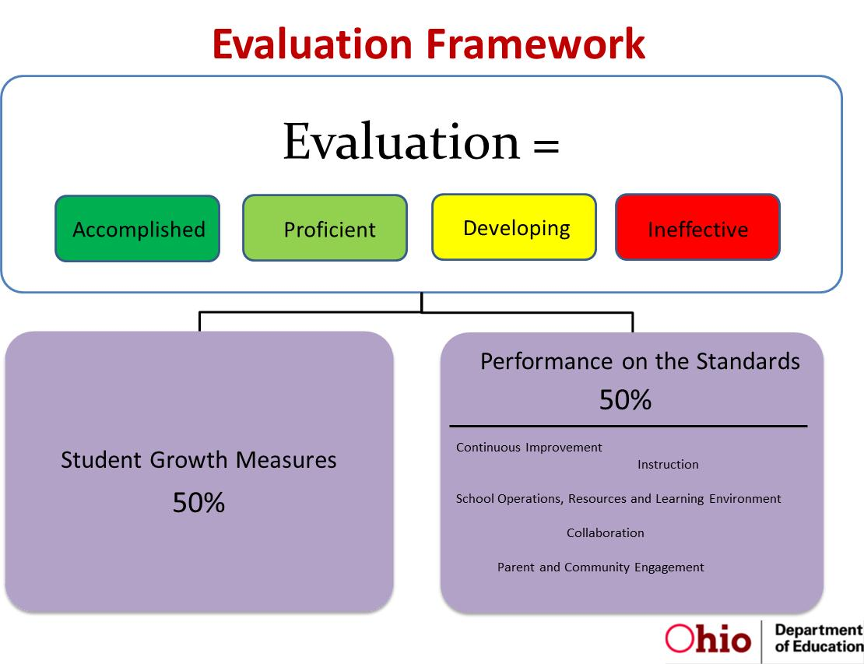

Tools for Teachers

New look and new address as of August 2012:


http://toolsforteachersohio.wordpress.com/

At this link, the Ohio Department of Education presents the new ePublication version of Tools for Teachers, its long-standing newsletter for Ohio educators. Whether this publication is new to you or a resource you’ve used in the past, we think you’ll benefit from its timely news, information and multi-media resources. Please share this link with your colleagues and candidates at your college or university.

Because Tools for Teachers is now interactive, we hope to improve our service to you through the feedback you give us by clicking the “Comment” button at the end of each article. We’ll send you notification of new and updated content bi-weekly, and we hope you’ll pass Tools along to other educators. You may unsubscribe any time.

ODE is committed to supporting teachers, future teachers and teacher educators in their service to Ohio’s students. We look forward to continuing our relationship with you.

PDK/Gallup Poll: Public Perception of Teachers
According to the recent Phi Delta Kappa/Gallup annual poll,
http://www.pdkintl.org/poll/docs/2012-Gallup-poll-full-report.pdf
"…three of four Americans say they have trust and confidence in the men and women who teach children in the public schools"--a finding that's stayed steady for the past three years.

Results from the 44th annual PDK/Gallup Poll of the Public’s Attitudes Toward the Public Schools show that Americans have a number of conflicting and hardening viewpoints in their appraisal of and preferences for directing, managing, and investing in the schools:
• We are divided on whether teachers should be evaluated based on student standardized test scores.
• We are divided on whether parents should receive vouchers to help pay for their children to attend private schools.
• We are divided on whether the children of immigrants who entered this country illegally should receive a free public education.
• We are divided on whether high school graduates are ready for college.
• We are even divided in how we perceive our schools, assigning the schools our children attend the highest grades ever while showing little confidence in the nation’s schools as a whole.
• And we are certainly divided on which political party and which presidential candidate can more positively influence public education in America.
Simultaneously and perhaps ironically, we agree on other important issues:
• We agree that teachers should be rigorously screened and prepared, at least to the level of other professions such as engineering, business, law, and medicine.
• We agree that we have trust and confidence in our teachers.
• We agree that the common core standards can have a positive affect on public education.
• We agree that neither high school dropouts nor high school graduates are ready for the world of work.
• We agree that we must close the achievement gap and that we can do this without lowering standards.
• We agree that we must support urban schools.

However, there's also been escalating negative rhetoric about teachers--or what president of the American Federation of Teachers Randi Weingarten has called the "demonization" of teachers--over the last few years, especially by politicians and other public figures.
As a teacher, how do you think the public perceives your profession? Does this affect your practice--and how? What could you and your colleagues do to alter public perceptions about your profession? Or, considering how many other responsibilities you have, should you leave that up to someone else? Ideally, how do you hope the public's view of teachers will change over the next 10 years?

