

FAQ- IHE Role in Title II Reporting

What is the Title II Report?
The Title II Institutional and Program Report Card on the Quality of Teacher Education is required in response to the Higher Education Act of 1965, as amended in 2008 by the Higher Education Opportunity Act. Institutions of higher education that conduct teacher preparation programs and enroll students who receive federal assistance must complete the report annually. The report is based on teacher candidates seeking INITIAL teaching licensure only; those seeking a second teaching license are NOT included in the report.

Who’s involved in the reporting process?
There are four entities involved in the reporting process:
- Institutions of higher education (IHEs);
- Westat, the federal contractor;
- Educational Testing Service (ETS), the organization that collects student information for purposes of providing assessment data and calculating pass rates; and
- The Center for the Teaching Profession at the Ohio Department of Education which annually submits the Title II State Report Card on the Quality of Teacher Preparation, provides support to the IHEs and serves, as needed, as intermediary among the three entities as noted above.

What are the steps in the Title II reporting process?

Step 1: Data entry of candidate information in the Educational Testing Service Title II web site. This occurs in the fall of each year, August-November.

What is the process?
Annually, IHEs enter candidates who have completed or were enrolled in their initial teaching preparation programs in the previous academic year into the Title II ETS web application. The purpose of this data entry is to provide candidate information so that ETS is able to extract pass rate data. Assessment data includes all Praxis and assessments provided by the American Council on the Teaching of Foreign Language (ACTFL) completed for purposes of initial licensure.

Weekly matches are scheduled so that IHEs can check candidate data and troubleshoot any problems. IHEs work with ETS to resolve issues related to matching candidates to data.

What are the categories of candidates entered into the ETS Title II system?
- Program completers are those who have met all educational or training requirements of a state-approved course of study to qualify for the initial teaching license.

- Enrolled candidates who have completed all non-clinical courses – This includes students in any course in the teacher preparation program curriculum that focuses on content and does not require students to participate in supervised clinical experience. As per Title II Tips for Reporting, “some programs may have no data to report on this item given the presence of program designs that incorporate activities that meet the definition of supervised clinical experiences into curricula in ways to disallow identification of those students who have completed all nonclinical courses.”

- Other Enrolled students –This includes students who have been admitted to a teacher preparation program but have not yet completed, students who are concurrently in clinical and non-clinical coursework, and those who have yet to take a non-clinical course following supervised clinical experience.

When does ETS calculate pass rates and provide data to IHEs?
From December to March, ETS extracts the pass rate data on the candidates that IHEs uploaded to the ETS website (September-November) and makes the data available in draft form to IHEs on its website. Any problems IHEs find with their data are resolved during the resolution period. (There is a $1500 fee involved with recalculating the pass rate data if the discrepancy is a result of an IHE error.) Beginning in 2012, ETS will deliver the assessment reports to Westat. IHEs will no longer be responsible for uploading their Praxis data into their federal report. These data will be provided to Westat who will upload the data in April .

What is the ETS Title II website? https://tlcs.ets.org

Step 2: Completion of the Title II Institutional and Program Report Card on the Quality of Teacher Preparation (February – April) on the federal website.

What is the process?
Annually, in February, Westat, the Title II contractor, opens the Title II website for IHEs to complete the federal report on the previous academic year. All reporting is done on-line. This website is open through April 30.

IHEs report on program information, goals and assurances, pass rates and scaled scores, statement and designation as low-performing, use of technology, teacher training, major subject, contextual information (optional) and certification. Some of the sections are preloaded with information from the previous year. These sections are updated as needed by the IHE.

What is the federal website? https://title2.ed.gov/Title2IPRC/default.aspx

What happens to the data that are entered into the IHE Title II reports?
Annually, ODE is required to complete the Title II State Report Card on the Quality of Teacher Preparation. Much of the information provided by the IHEs is folded into the state report. These data include assessment pass rates, major and subject and entrance requirements.

Special notes…
- The terms “Title II” and “Title 2” are used interchangeably.

- The terms “students” and “candidates” are used interchangeably.

- ETS and Westat maintain a list of contacts for each IHE.
- ETS has a contact verification form on its website. Email is sent to IHEs in the summer informing them of how to verify the contact and sends information to the contacts regarding the particulars of when and how to report students.
- Westat contacts ODE to verify the IHE contact list. In addition, IHEs will receive a form from ODE to complete and return regarding the IHE person assigned for data entry of the Title II report. Westat communicates with the IHE contacts regarding the particulars of when and how to complete the IHE report.

- Search the technical assistance section of each website for documents helpful to the process.

- Be mindful of the timelines and start the data entry process early. The more lead time IHEs have the easier the troubleshooting of any problems.

- Annually, states are required to complete the Title II State Report Card on the Quality of Teacher Preparation. The federal Title II website houses all the states’ reports beginning with 2001.

- All of the programs at Ohio’s IHEs are categorized as “traditional teacher preparation program within IHE.” If the IHE is the recommending body for the teaching license, then the program is traditional. Enter all students in the ETS Title2 website in the category: traditional teacher preparation program within IHE. And remember that this report is based on those seeking INITIAL teaching licensure only. Those seeking a second teaching license and licenses for professional pupil services and administrators ARE NOT included. Candidates recommended by a local superintendent for the initial Alternative Resident Educator license are not part of the Title II report.

- Specified dates for opening and closing of websites may be subject to change.

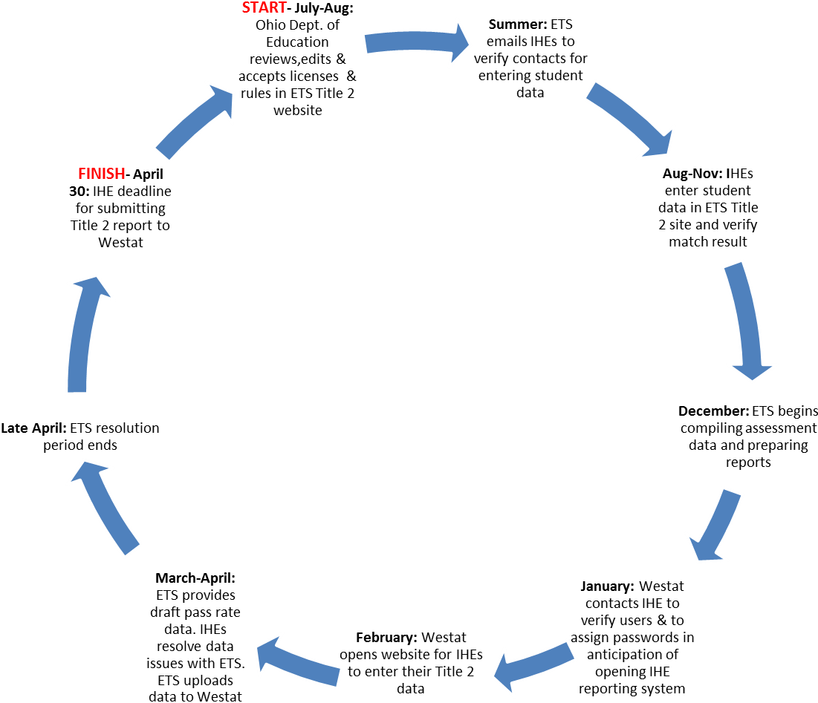
Timeline for
IHE Title II
Reporting

